# Report 4: Software Design Description

## Design Overview

This document describes the technical and user interface design of MSSC System. It includes the architectural design, the detailed design of common functions and business functions and the design of database model.

The architectural design describes the overall architecture of the system and the architecture of each main component and subsystem.

The detailed design describes static and dynamic structure for each component and functions. It includes class diagrams, class explanations and sequence diagrams for each use cases.

The database design describes the relationships between entities and details of each entity.

Document overview:

* Section 2: gives an overall description of the system architecture design.
* Section 3: gives component diagrams that describe the connection and integration of the system.
* Section 4: gives the detail design description which includes class diagram, class explanation, and sequence diagram to details the application functions.
* Section 5: overview some main user interface of system.
* Section 6: describe fully attributed ERD.
* Section 7: describe in details all algorithms used in the system.

## System Architectural Design

### Choice of System Architecture

The system is developed using MVC architecture, combine with front end – back end RESTful Web service interface architecture.

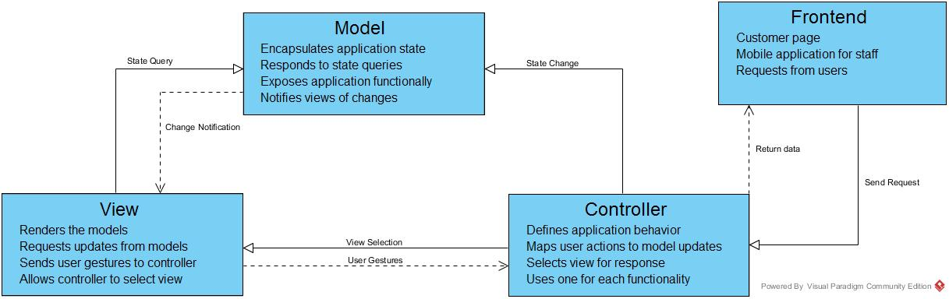

## Component Diagram

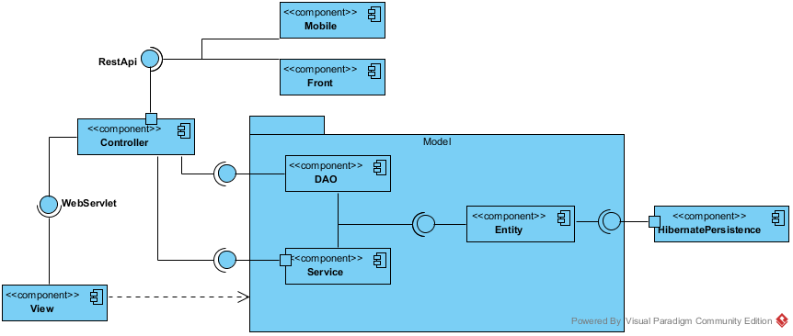

Figure : Component Diagram

## Detailed Description Explanation

### Class Diagram

#### Entity Package Class Diagram

Figure : Class Diagram

#### Class Diagram Explanation

##### Class 1

Attribute

|  |  |  |  |
| --- | --- | --- | --- |
| **Attribute** | **Type** | **Visibility** | **Description** |
|  |  |  |  |

Method

|  |  |  |  |
| --- | --- | --- | --- |
| **Attribute** | **Type** | **Visibility** | **Description** |
|  |  |  |  |

##### Class 2

Attribute

|  |  |  |  |
| --- | --- | --- | --- |
| **Attribute** | **Type** | **Visibility** | **Description** |
|  |  |  |  |

Method

|  |  |  |  |
| --- | --- | --- | --- |
| **Attribute** | **Type** | **Visibility** | **Description** |
|  |  |  |  |

#### DAO Package Class Diagram

Figure : Class Diagram

#### Class Diagram Explanation

##### Class 1

Attribute

|  |  |  |  |
| --- | --- | --- | --- |
| **Attribute** | **Type** | **Visibility** | **Description** |
|  |  |  |  |

Method

|  |  |  |  |
| --- | --- | --- | --- |
| **Attribute** | **Type** | **Visibility** | **Description** |
|  |  |  |  |

##### Class 2

Attribute

|  |  |  |  |
| --- | --- | --- | --- |
| **Attribute** | **Type** | **Visibility** | **Description** |
|  |  |  |  |

Method

|  |  |  |  |
| --- | --- | --- | --- |
| **Attribute** | **Type** | **Visibility** | **Description** |
|  |  |  |  |

#### Service Package Class Diagram

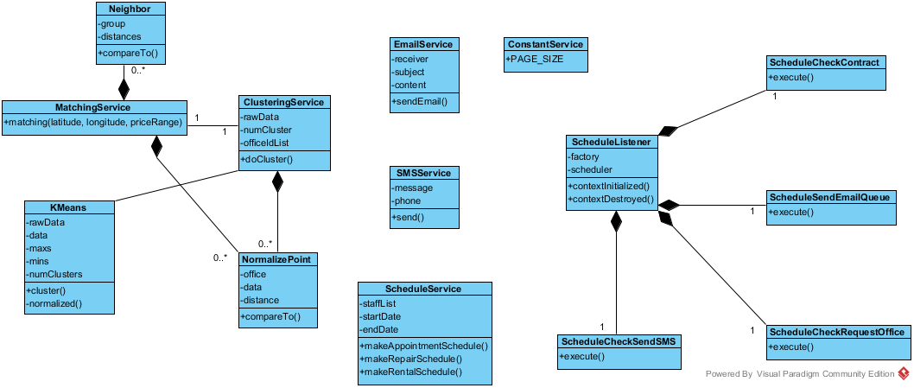

Figure : Service Package Class Diagram

#### Class Diagram Explanation

##### EmailService

Attribute

|  |  |  |  |
| --- | --- | --- | --- |
| **Attribute** | **Type** | **Visibility** | **Description** |
| receiver | String | private | The recipient of the email |
| subject | String | private | The subject of the email |
| content | String | private | The content of the email |

Method

|  |  |  |  |
| --- | --- | --- | --- |
| **Attribute** | **Type** | **Visibility** | **Description** |
| sendEmail | boolean | public | Send the email with the subject and content to the receiver |

##### SMSService

Attribute

|  |  |  |  |
| --- | --- | --- | --- |
| **Attribute** | **Type** | **Visibility** | **Description** |
| message | String | private | The SMS message will be sent |
| phone | String | private | The phone number of the recipient |

Method

|  |  |  |  |
| --- | --- | --- | --- |
| **Attribute** | **Type** | **Visibility** | **Description** |
| send() | String | public | Send the SMS message to the recipient. Return “SUCCESS” if sent success, otherwise return the error message form the service provider |

##### ConstantService

Attribute

|  |  |  |  |
| --- | --- | --- | --- |
| **Attribute** | **Type** | **Visibility** | **Description** |
| PAGE_SIZE | int | public | The constant for the page size of the list in admin pages |

##### ScheduleService

Attribute

|  |  |  |  |
| --- | --- | --- | --- |
| **Attribute** | **Type** | **Visibility** | **Description** |
| staffList | List<Staff> | private | The list of all staff for the service |
| startDate | DateTime | private | The start date of the week for the schedule |
| endDate | DateTime | private | The end date of the week for the schedule |

Method

|  |  |  |  |
| --- | --- | --- | --- |
| **Attribute** | **Type** | **Visibility** | **Description** |
| makeAppointmentSchedule() | Map | public | Return the schedule hash map with appointment id and staff username for the unassigned appointment |
| makeRepairSchedule() | Map | public | Return the schedule hash map with repair id and pre-arranged repair for the unassigned repair |
| makeRentalSchedule() | Map | public | Return the schedule hash map with rental id and pre-arranged rental for the unassigned rental |

##### KMeans

Attribute

|  |  |  |  |
| --- | --- | --- | --- |
| **Attribute** | **Type** | **Visibility** | **Description** |
| rawData | double[][] | private | The raw data for k-means algorithm |
| data | double[][] | private | The normalized data for k-means algorithm |
| maxs | double[] | private | The array for max value of each dimension of k-means |
| mins | double[] | private | The array for min value of each dimension of k-means |
| numClusters | int | private | The number of cluster (k) in k-means algorithm |

Method

|  |  |  |  |
| --- | --- | --- | --- |
| **Attribute** | **Type** | **Visibility** | **Description** |
| cluster | double[] | public | Do the k-means algorithm. Return the array of group id for each of input data |
| normalized | double[][] | private | Normalize the raw data |

##### ClusteringService

Attribute

|  |  |  |  |
| --- | --- | --- | --- |
| **Attribute** | **Type** | **Visibility** | **Description** |
| rawData | double[][] | private | The input raw data of all office |
| numCluster | int | private | The calculated k-means number |
| officeIdList | int[] | private | List of all office id |

Method

|  |  |  |  |
| --- | --- | --- | --- |
| **Attribute** | **Type** | **Visibility** | **Description** |
| doCluster | int[] | public | Do the k-means clustering for all office. The result is saved to database also return the array of office group by all office |

##### NormalizePoint

Attribute

|  |  |  |  |
| --- | --- | --- | --- |
| **Attribute** | **Type** | **Visibility** | **Description** |
| office | Office | private | Use to store the office for clustering service |
| data | double[] | private | The normalize data for current office |
| distance | double | private | The distance between the data point and query point in MatchingService |

Method

|  |  |  |  |
| --- | --- | --- | --- |
| **Attribute** | **Type** | **Visibility** | **Description** |
| compareTo() | int | public | Return the compare result of 2 NormalizePoint |

##### MatchingService

Method

|  |  |  |  |
| --- | --- | --- | --- |
| **Attribute** | **Type** | **Visibility** | **Description** |
| matching() | List<Office> | public | Do the matching group for the input office point and the all office data. Return the list of matched office group sort by relevant |

##### Neighbor

Attribute

|  |  |  |  |
| --- | --- | --- | --- |
| **Attribute** | **Type** | **Visibility** | **Description** |
| group | int | private | The index of the office group |
| distances | List<Double> | private | The list of distance of query point and office in group for the KNN matching service |

Method

|  |  |  |  |
| --- | --- | --- | --- |
| **Attribute** | **Type** | **Visibility** | **Description** |
| compareTo() | int | public | Compare distance between query point and two list of data |

##### ScheduleListener

Attribute

|  |  |  |  |
| --- | --- | --- | --- |
| **Attribute** | **Type** | **Visibility** | **Description** |
| factory | SchedulerFactory | private | The factory for initiate the scheduler |
| scheduler | Scheduler | private | The class contain the instance of the scheduler factory |

Method

|  |  |  |  |
| --- | --- | --- | --- |
| **Attribute** | **Type** | **Visibility** | **Description** |
| contextInitialized() | void | public | Override context listener when the app initialized |
| contextDestroyed() | void | public | O Override context listener when the app destroyed |

##### ScheduleCheckContract

Method

|  |  |  |  |
| --- | --- | --- | --- |
| **Attribute** | **Type** | **Visibility** | **Description** |
| execute | void | public | Execute the schedule for check the contract due date. Cancel the contract if the contract at due date |

##### ScheduleCheckRequestOffice

Method

|  |  |  |  |
| --- | --- | --- | --- |
| **Attribute** | **Type** | **Visibility** | **Description** |
| execute | void | public | Execute the schedule for check the Request office. Stored the found office and queue to send an email to customer |

##### ScheduleCheckSendSMS

Method

|  |  |  |  |
| --- | --- | --- | --- |
| **Attribute** | **Type** | **Visibility** | **Description** |
| execute | void | public | Execute the schedule for check the appointment date. Send a SMS to user if the appointment date is near |

##### ScheduleCheckEmailQueue

Method

|  |  |  |  |
| --- | --- | --- | --- |
| **Attribute** | **Type** | **Visibility** | **Description** |
| execute | void | public | Execute the schedule for check the email in queue to send |

#### Controller Package Class Diagram

Figure : Class Diagram

#### Class Diagram Explanation

##### Class 1

Attribute

|  |  |  |  |
| --- | --- | --- | --- |
| **Attribute** | **Type** | **Visibility** | **Description** |
|  |  |  |  |

Method

|  |  |  |  |
| --- | --- | --- | --- |
| **Attribute** | **Type** | **Visibility** | **Description** |
|  |  |  |  |

##### Class 2

Attribute

|  |  |  |  |
| --- | --- | --- | --- |
| **Attribute** | **Type** | **Visibility** | **Description** |
|  |  |  |  |

Method

|  |  |  |  |
| --- | --- | --- | --- |
| **Attribute** | **Type** | **Visibility** | **Description** |
|  |  |  |  |

#### View Package Class Diagram

Figure : Class Diagram

#### Class Diagram Explanation

##### Class 1

Attribute

|  |  |  |  |
| --- | --- | --- | --- |
| **Attribute** | **Type** | **Visibility** | **Description** |
|  |  |  |  |

Method

|  |  |  |  |
| --- | --- | --- | --- |
| **Attribute** | **Type** | **Visibility** | **Description** |
|  |  |  |  |

##### Class 2

Attribute

|  |  |  |  |
| --- | --- | --- | --- |
| **Attribute** | **Type** | **Visibility** | **Description** |
|  |  |  |  |

Method

|  |  |  |  |
| --- | --- | --- | --- |
| **Attribute** | **Type** | **Visibility** | **Description** |
|  |  |  |  |

#### Front Package Class Diagram

Figure : Class Diagram

#### Class Diagram Explanation

##### Class 1

Attribute

|  |  |  |  |
| --- | --- | --- | --- |
| **Attribute** | **Type** | **Visibility** | **Description** |
|  |  |  |  |

Method

|  |  |  |  |
| --- | --- | --- | --- |
| **Attribute** | **Type** | **Visibility** | **Description** |
|  |  |  |  |

##### Class 2

Attribute

|  |  |  |  |
| --- | --- | --- | --- |
| **Attribute** | **Type** | **Visibility** | **Description** |
|  |  |  |  |

Method

|  |  |  |  |
| --- | --- | --- | --- |
| **Attribute** | **Type** | **Visibility** | **Description** |
|  |  |  |  |

#### Mobile Package Class Diagram

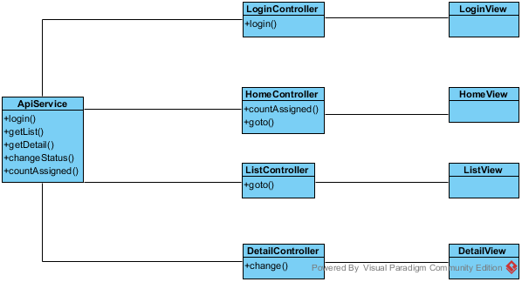

Figure : Mobile Package Class Diagram

#### Class Diagram Explanation

##### ApiService

Method

|  |  |  |  |
| --- | --- | --- | --- |
| **Attribute** | **Type** | **Visibility** | **Description** |
| login() | function | public | Call the login api and return the result. |
| getList() | function | public | Call the getList api to return the list of job for current staff (appointment/rental/repair) |
| getDetail() | function | public | Call the getDetail api to return the detail of current job |
| countAssigned() | function | public | Call the countAssigned api to return the number of assigned for current job |
| changeStatus() | function | public | Call the changeStatus api to change the status of current job |

##### LoginController

Attribute

|  |  |  |  |
| --- | --- | --- | --- |
| **Attribute** | **Type** | **Visibility** | **Description** |
| username | string | private | The inputted username |
| password | string | private | The inputted password |

Method

|  |  |  |  |
| --- | --- | --- | --- |
| **Attribute** | **Type** | **Visibility** | **Description** |
| login() | function | private | Call the login function of ApiService |

##### LoginView

This is the presentation view of LoginController

##### HomeController

Attribute

|  |  |  |  |
| --- | --- | --- | --- |
| **Attribute** | **Type** | **Visibility** | **Description** |
| title | string | private | The title of the job (appointment/rental/repair) |
| badge | Array | private | The array of number of assigned job |

Method

|  |  |  |  |
| --- | --- | --- | --- |
| **Attribute** | **Type** | **Visibility** | **Description** |
| countAssigned() | function | private | Call the countAssigned function of ApiService to get the job number |
| goto() | function | private | Go to the list page of the job |

##### HomeView

This is the presentation view of HomeController

##### ListController

Attribute

|  |  |  |  |
| --- | --- | --- | --- |
| **Attribute** | **Type** | **Visibility** | **Description** |
| title | string | private | The title of the job (appointment/rental/repair) |
| data | Array | private | The array of the detail of job |

Method

|  |  |  |  |
| --- | --- | --- | --- |
| **Attribute** | **Type** | **Visibility** | **Description** |
| goto() | function | private | Go to the detail page of the job |

##### ListView

This is the presentation view of ListController

##### DetailController

Attribute

|  |  |  |  |
| --- | --- | --- | --- |
| **Attribute** | **Type** | **Visibility** | **Description** |
| title | string | private | The title of the job (appointment/rental/repair) |
| data | object | private | The detail of job |

Method

|  |  |  |  |
| --- | --- | --- | --- |
| **Attribute** | **Type** | **Visibility** | **Description** |
| change() | function | private | Call the api to change the status of the job |

##### DetailView

This is the presentation view of DetailController

### Interaction Diagram

#### <Manager> View Appointment Request List

**Summary:** This diagram used to describe the process of manager view all appointment requests.

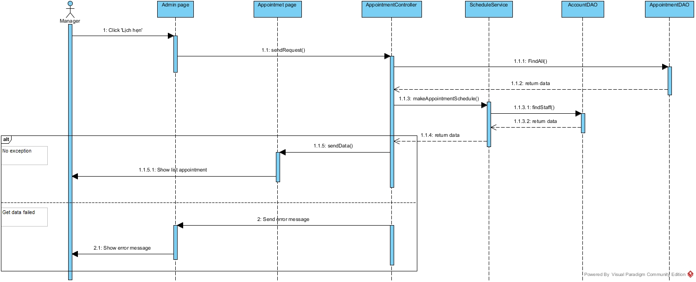

Figure : View Appointment Request List

#### <Manager> Assign Appointment

**Summary:** This diagram used to describe the process of manager assign appointment requests to staff.

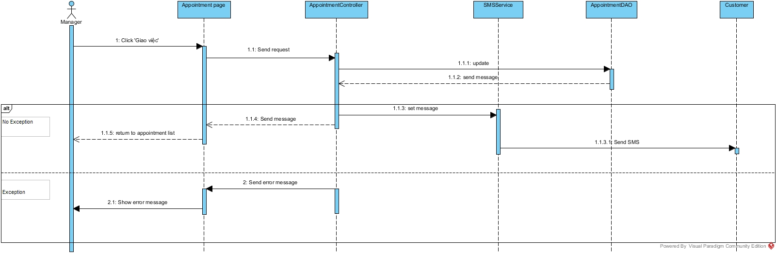

Figure : Assign Appointment

#### <Manager> Cancel Appointment

**Summary:** This diagram used to describe the process of manager cancel appointment

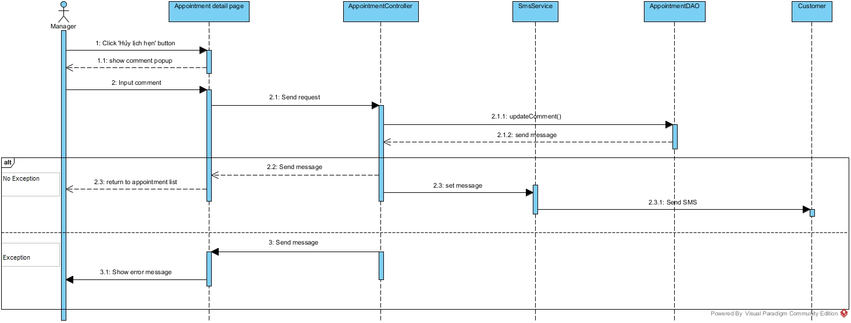

Figure : Cancel Appointment

#### <Manager> Create Contract

**Summary:** This diagram used to describe the process of manager create contract

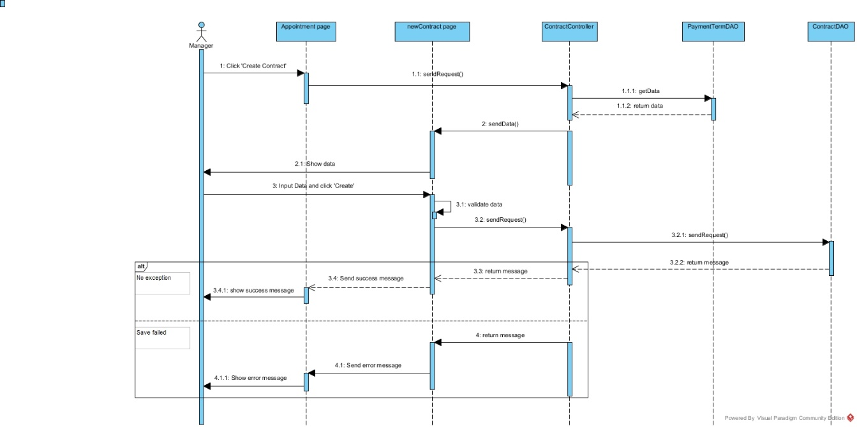

Figure : Create Contract

#### <Manager> View Contract List

**Summary:** This diagram used to describe the process of manager view contract list

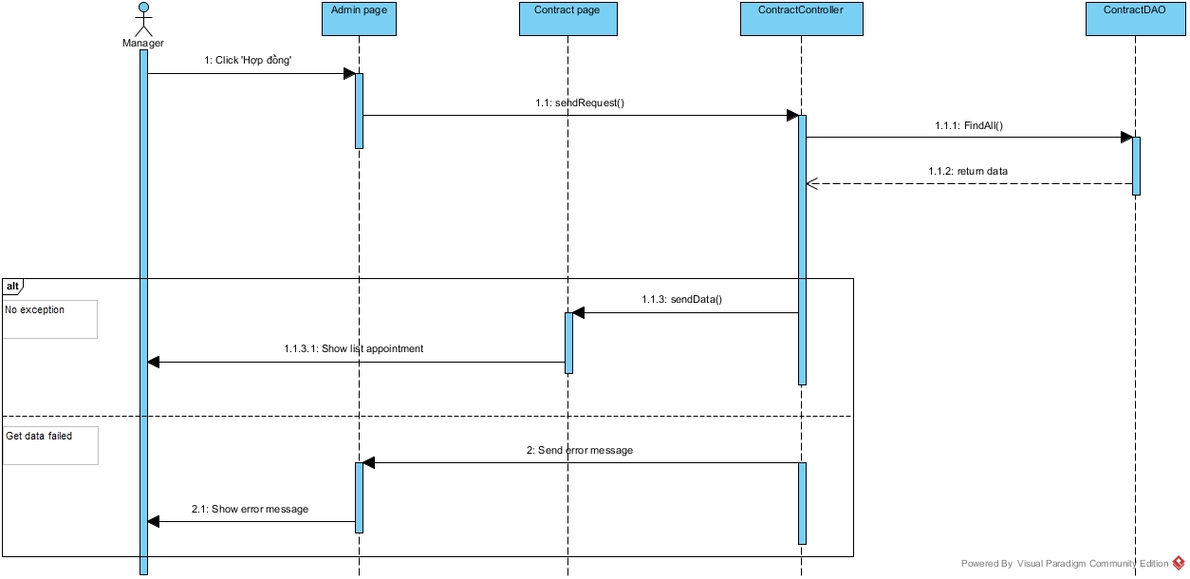

Figure : View Contract List

#### <Manager> View Contract Detail

**Summary:** This diagram used to describe the process of manager view contract detail

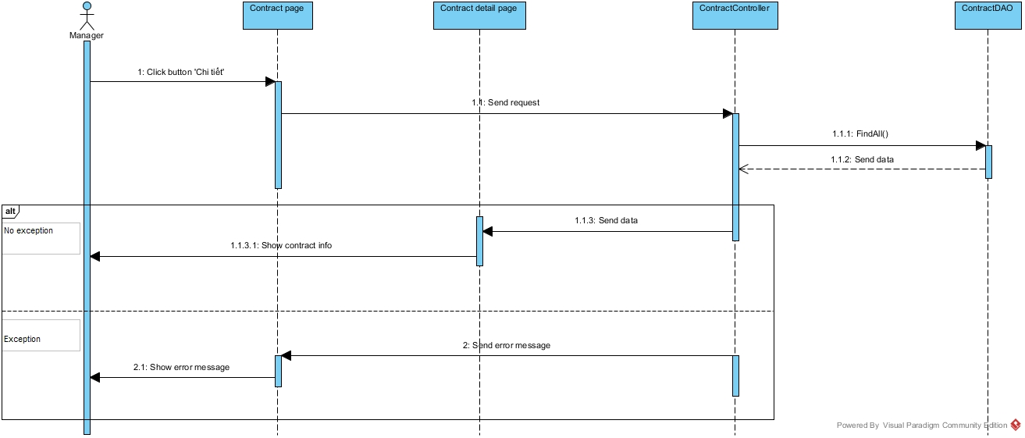

Figure : View Contract Detail

#### <Manager> Edit Contract

**Summary:** This diagram used to describe the process of manager edit contract.

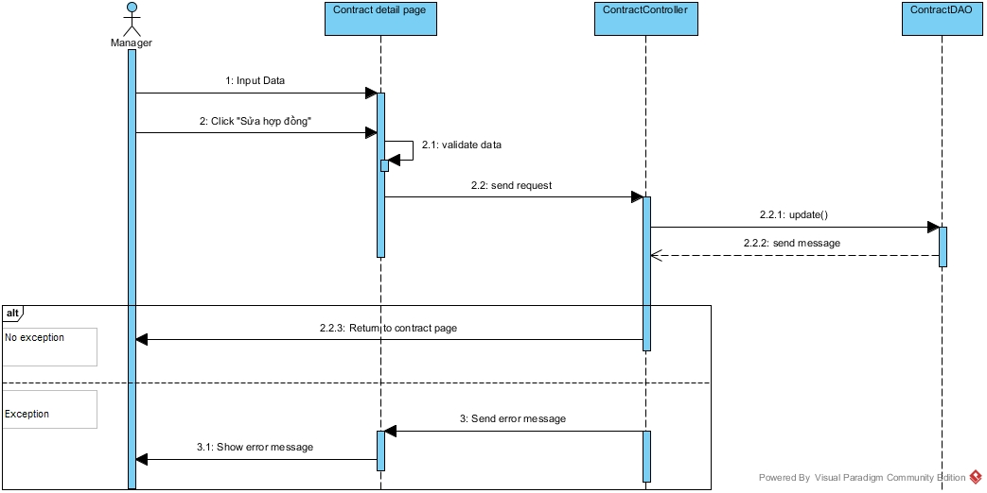

Figure : Edit Contract

#### <Manager> View Repair Request

**Summary:** This diagram used to describe the process of manager view repair requests.

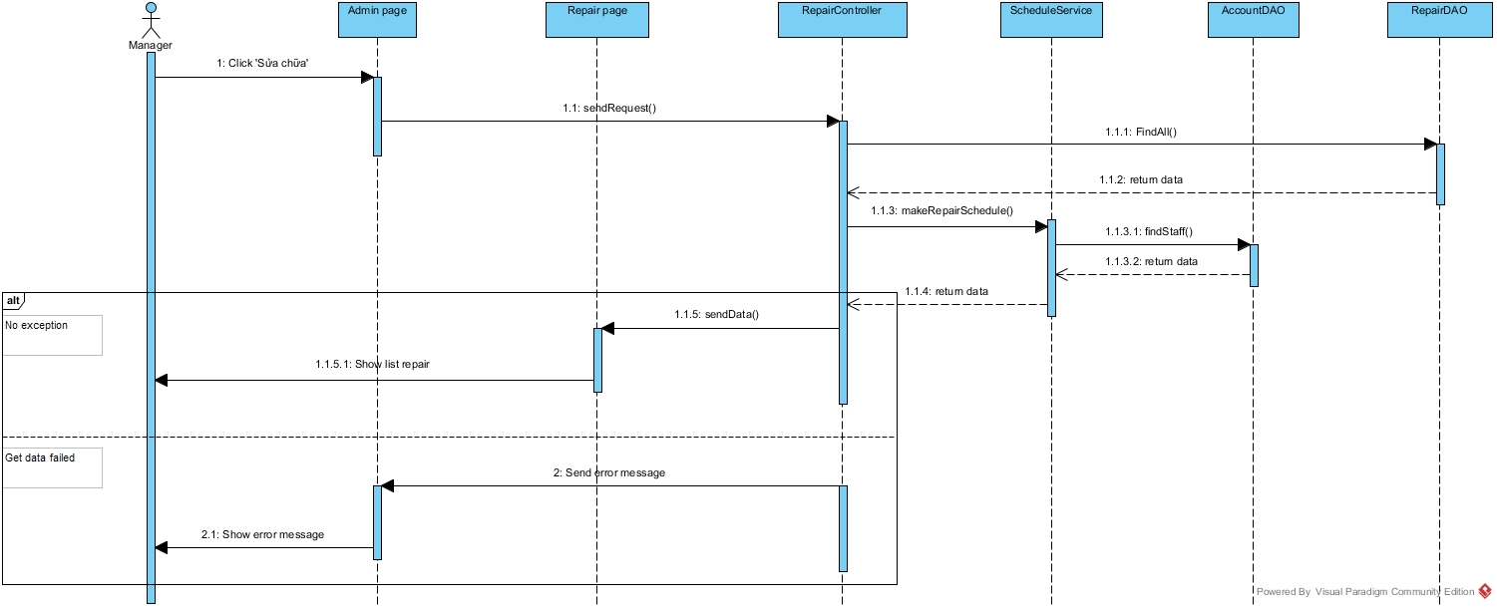

Figure : View Repair Request

#### <Manager> Assign Repair Request

**Summary:** This diagram used to describe the process of manager assign repair requests to staff.

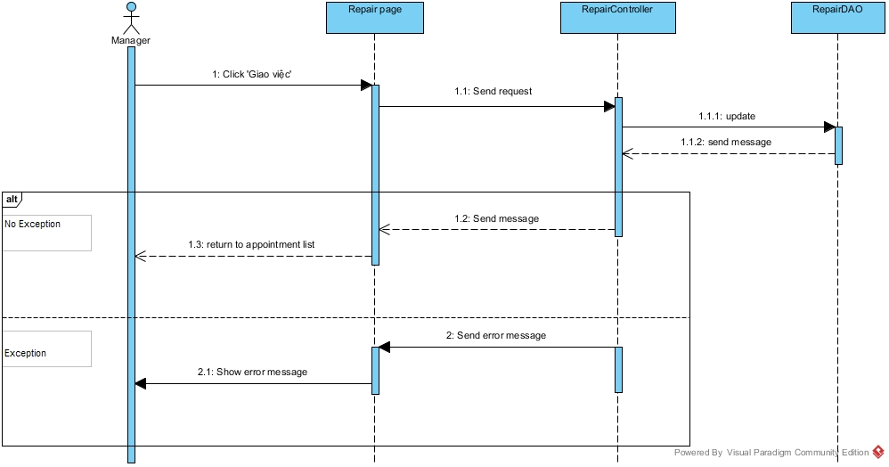

Figure : Assign Repair Request

#### <Manager> Cancel Repair Request

**Summary:** This diagram used to describe the process of manager cancel repair requests.

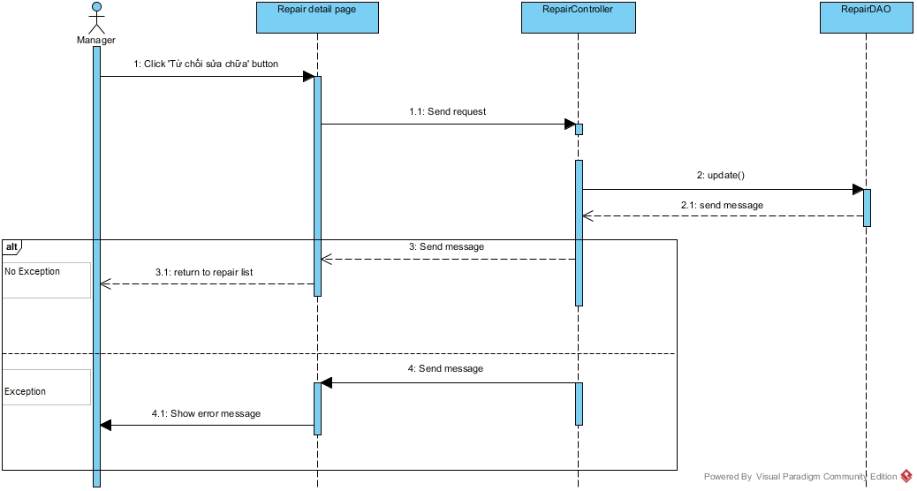

Figure : Cancel Repair Request

#### <Manager> View Rental Request

**Summary:** This diagram used to describe the process of manager view rental requests.

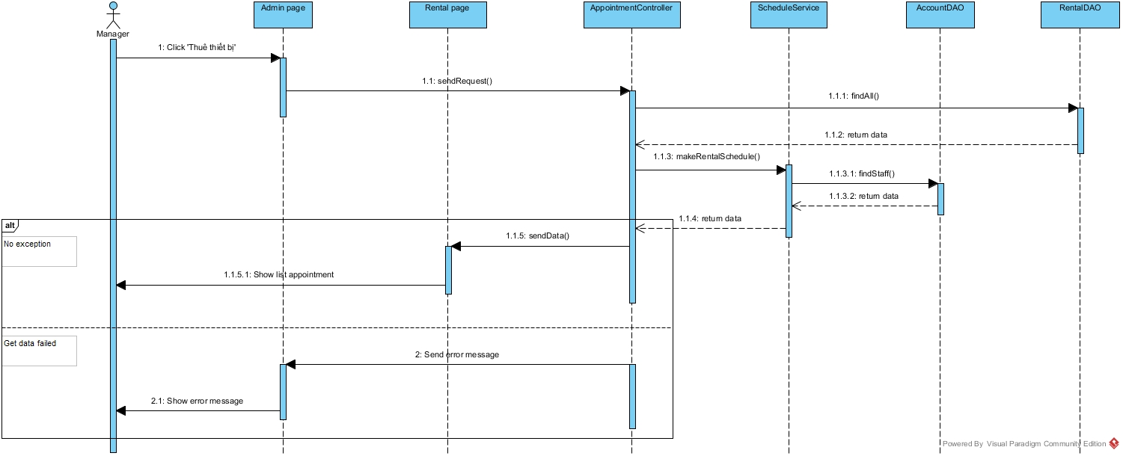

Figure : View Rental Request

#### <Manager> Assign Rental Request

**Summary:** This diagram used to describe the process of manager assign rental requests to staff.

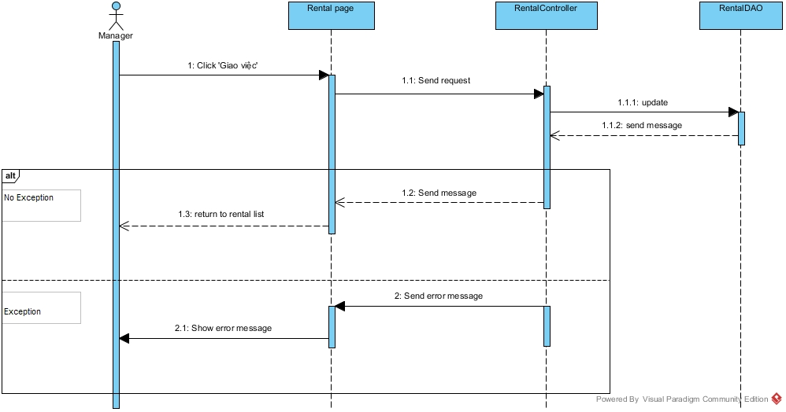

Figure : Assign Rental request

#### <Manager> Cancel Rental Request

**Summary:** This diagram used to describe the process of manager cancel rental request.

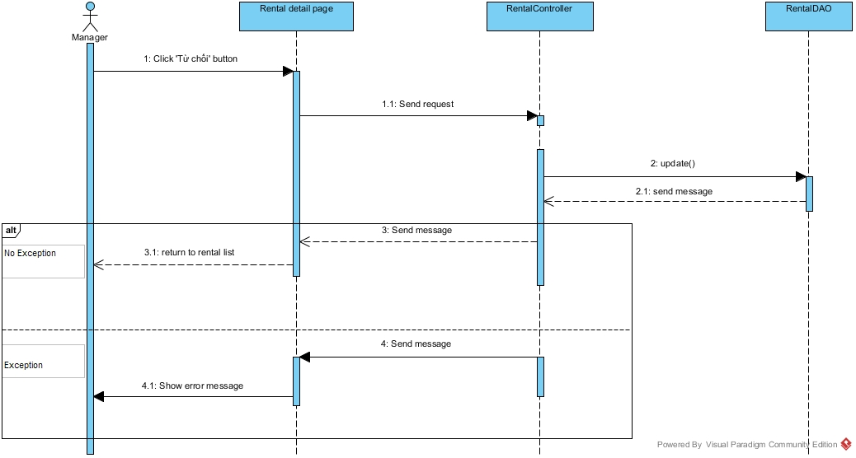

Figure : Cancel Rental Request

#### <Customer> View Result Request Office

**Summary:** This diagram used to describe the process of customer view result request office.

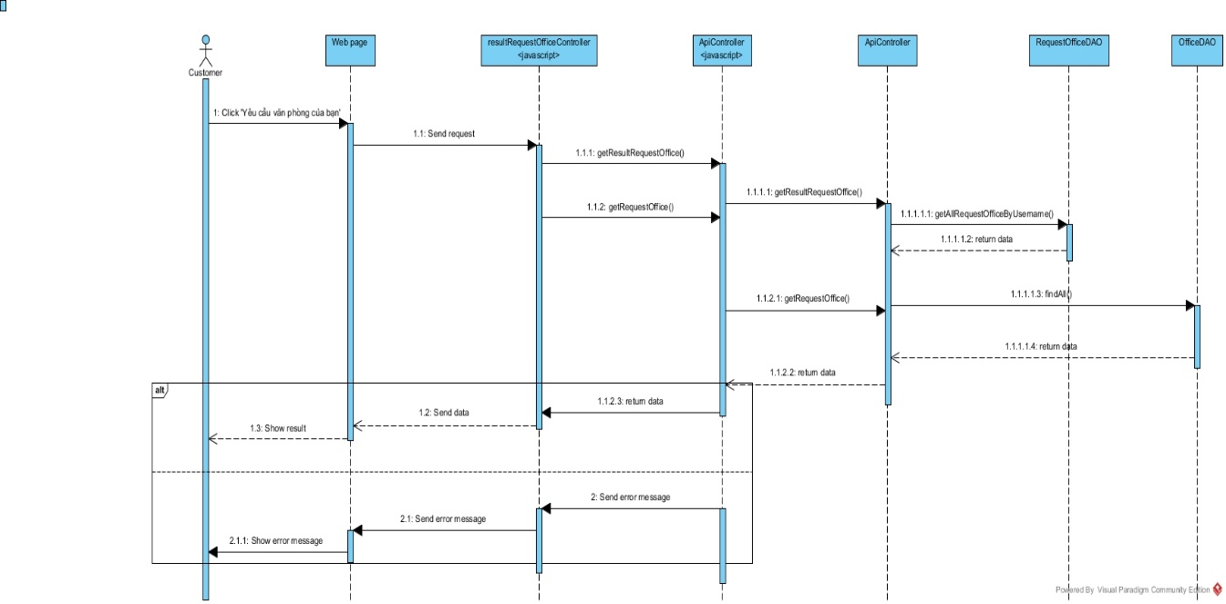

Figure : View Result Request Office

#### <System> Check Contract Due Date

**Summary:** This diagram used to describe the process of system check contract due date.

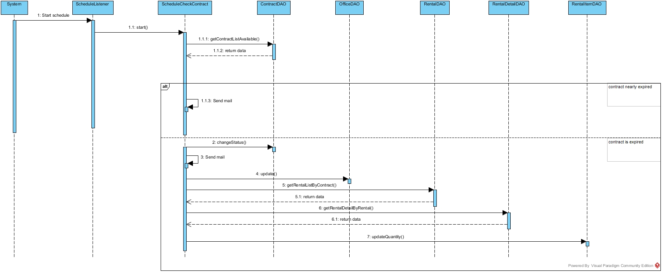

Figure : Check Contract Due Date

#### <System> Suggest Request Office

**Summary:** This diagram used to describe the process of system suggest request office to customer.

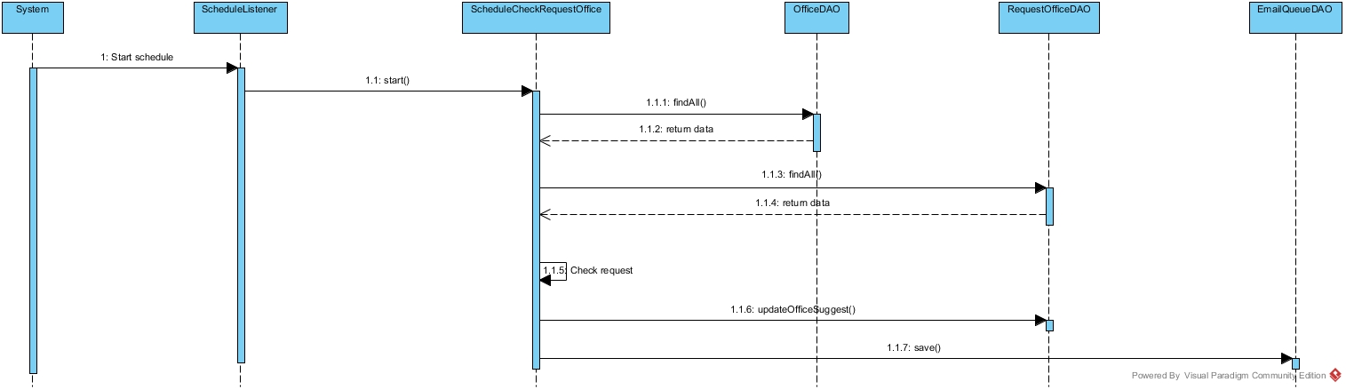

Figure : Suggest Request Office

## Database Design

### Logical Diagram

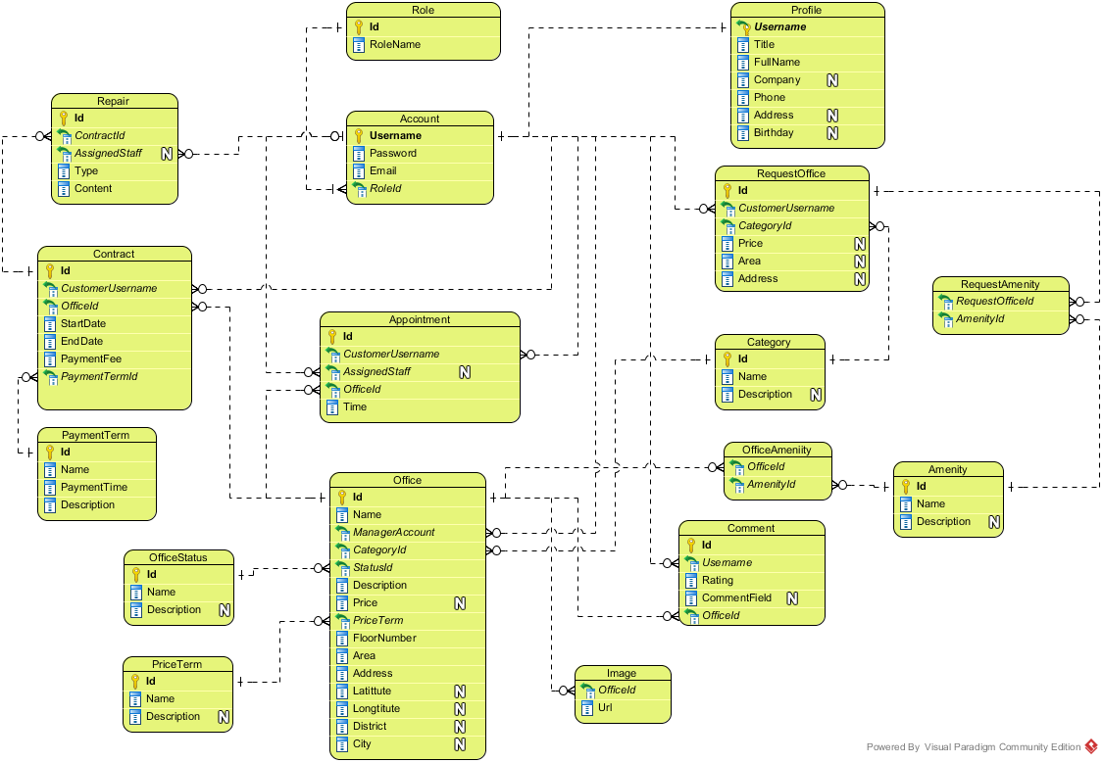

**Figure 17: Logical Database Diagram**

### Data Dictionary

|  |  |
| --- | --- |
| **Entity Data dictionary: describe content of all entities** | |
| **Entity Name** | **Description** |
| Account | Describe all accounts of users in the system. |
| Account Status | Describe status of account. One account has only one status. |
| Amenity | Describe all amenities in system. |
| Amenity Group | Describe groups of amenity. One amenity is only in one group. |
| Appointment | Describe all appointment requests of customer. |
| Appointment Status | Describe status of appointment request. One appointment has only one status. |
| Category | Describe category of office. One office is only in one category. |
| Contract | Describe all contracts in the system. |
| Contract Status | Describe status of contract. One contract has only one status. |
| Email Queue | Describe all emails have to send to customer in the system. |
| Office | Describe all offices in the system. |
| Office Amenity | Describe all amenities in one office. One office can have more than one amenity. |
| Office Group | Describe group of the office for searching office. One office is only in one group |
| Office Status | Describe status of the office. One office has only one status. |
| Payment Term | Describe time for the payment |
| Price Term | Describe the way that money is calculated base on. |
| Profile | Describe information of the account |
| Rental | Describe all rental requests from customer |
| Rental Detail | Describe all rental items for one rental request |
| Rental Item | Describe all rental items in system |
| Rental Status | Describe status of rental request. One rental request has only one status. |
| Repair | Describe all repair requests from customer |
| Repair Detail | Describe all amenities need to repair for one repair request |
| Repair Status | Describe status of repair request. One repair request has only one status. |
| Request Amenity | Describe all amenities in one request office |
| Request Office | Describe all requests office from customer |
| Role | Describe role of account. One account has only one role. |

#### Table Account

|  |  |  |  |  |
| --- | --- | --- | --- | --- |
| **Entity name** | **Attributes** | **Description** | **Type** | **Null** |
| Account | Username{PK} | Unique identifier of an account, username for login to system | nvarchar(50) | No |
| Password | Password for login to system | varchar(50) | No |
| Email | Email of this account | varchar(50) | No |
| RoleId{FK} | Role of this account. Foreign key references to table Role | int | No |
| StatusId{FK} | Status of this account. Foreign key references to table Account Status | int | No |
| Unique Key: Email | | | | |

#### Table Account Status

|  |  |  |  |  |
| --- | --- | --- | --- | --- |
| **Entity name** | **Attributes** | **Description** | **Type** | **Null** |
| Account Status | Id{PK} | Unique identifier of an account status, automatically increase | int | No |
| Name | Name of this status | nvarchar(50) | No |
| Description | Description for this status | nvarchar(50) | Yes |

#### Table Amenity

|  |  |  |  |  |
| --- | --- | --- | --- | --- |
| **Entity name** | **Attributes** | **Description** | **Type** | **Null** |
| Amenity | Id{PK} | Unique identifier of an amenity, automatically increase | int | No |
| Name | Name of this amenity | nvarchar(50) | No |
| Description | Description for this amenity | nvarchar(250) | Yes |
| Weight | Weight of amenity in one group | int | Yes |
| AmenityGroupId{FK} | Group of this amenity. Foreign key references to table Amenity Group | int | Yes |
| Priority | Priority of amenity in one group | int | Yes |
| Unique Key: Weight | | | | |

#### Table Amenity Group

|  |  |  |  |  |
| --- | --- | --- | --- | --- |
| **Entity name** | **Attributes** | **Description** | **Type** | **Null** |
| Amenity Group | Id{PK} | Unique identifier of an amenity group, automatically increase | int | No |
| Name | Name of amenity group | nvarchar(50) | No |
| Description | Description for amenity group | nvarchar(250) | Yes |

#### Table Appointment

|  |  |  |  |  |
| --- | --- | --- | --- | --- |
| **Entity name** | **Attributes** | **Description** | **Type** | **Null** |
| Appointment | Id{PK} | Unique identifier of an appointment, automatically increase | int | No |
| CustomerUsername{FK} | Username of customer. Foreign key references to table Account | nvarchar(50) | No |
| AssignedStaff{FK} | Staff who is responsibility for the appointment. Foreign key references to table Account | nvarchar(250) | Yes |
| OfficeId{FK} | Office where customer want to make appointment. Foreign key references to table Office. | int | No |
| Time | Time for appointment | datetime | No |
| StatusId{FK} | Status of the appointment. Foreign key references to table appointment status. | int | No |
| CreateTime | Time when customer create appointment | datetime | No |
| UpdateTime | Time when manager update the appointment | datetime | Yes |
| Comment | Comment for the appointment | nvarchar(250) | Yes |

#### Table Appointment Status

|  |  |  |  |  |
| --- | --- | --- | --- | --- |
| **Entity name** | **Attributes** | **Description** | **Type** | **Null** |
| Appointment Status | Id{PK} | Unique identifier of an appointment status, automatically increase | int | No |
| Name | Name of appointment status | nvarchar(50) | No |
| Description | Description for appointment status | nvarchar(50) | Yes |

#### Table Category

|  |  |  |  |  |
| --- | --- | --- | --- | --- |
| **Entity name** | **Attributes** | **Description** | **Type** | **Null** |
| Category | Id{PK} | Unique identifier of a category for office, automatically increase | int | No |
| Name | Name of category | nvarchar(50) | No |
| Description | Description for category | nvarchar(250) | No |
| Unique Key: Name | | | | |

#### Table Contract

|  |  |  |  |  |
| --- | --- | --- | --- | --- |
| **Entity name** | **Attributes** | **Description** | **Type** | **Null** |
| Contract | Id{PK} | Unique identifier of a contract, automatically increase | int | No |
| CustomerUsername{FK} | Username of customer. Foreign key references to table Account | nvarchar(50) | No |
| OfficeId{FK} | Office where customer want to make contract. Foreign key references to table Office. | int | No |
| StartDate | Date when contract starts. | date | No |
| EndDate | Date when contract ends. | date | No |
| PaymentFee | Fee for the contract | int | No |
| PaymentTerm{FK} | Payment term for the contract. Foreign key references to table Payment Term. | int | No |
| StatusId{FK} | Status of the contract. Foreign key references to table contract status. | int |  |
| Comment | Comment for the appointment | nvarchar(250) | Yes |

#### Table Contract Status

|  |  |  |  |  |
| --- | --- | --- | --- | --- |
| **Entity name** | **Attributes** | **Description** | **Type** | **Null** |
| Contract Status | Id{PK} | Unique identifier of a contract status, automatically increase | int | No |
| Name | Name of contract status | nvarchar(50) | No |
| Description | Description for contract status | nvarchar(50) | Yes |

#### Table Email Queue

|  |  |  |  |  |
| --- | --- | --- | --- | --- |
| **Entity name** | **Attributes** | **Description** | **Type** | **Null** |
| Email Queue | Id{PK} | Unique identifier of an email queue, automatically increase | int | No |
| Username{FK} | Username of the customer. Foreign key references to table Account. | nvarchar(50) | No |
| OfficeIds | List office that system suggests to customer | nvarchar(50) | Yes |
| CreateTime | Time when customer create request | datetime | Yes |

#### Table Office

|  |  |  |  |  |
| --- | --- | --- | --- | --- |
| **Entity name** | **Attributes** | **Description** | **Type** | **Null** |
| Office | Id{PK} | Unique identifier of an office, automatically increase | int | No |
| Name | Name of the office. | nvarchar(50) | No |
| CategoryId{FK} | Category of the office. Foreign key references to table Category. | int | No |
| StatusId | Status of the office. Foreign key references to table Office Status. | int | No |
| Description | Description for the office | ntext | No |
| Price | Price of the office | bigint | Yes |
| PriceTerm{FK} | Price term of the office. Foreign key references to table Price Term. | int | No |
| FloorNumber | Number of floor in the office | int | No |
| Area | Area of the office | float | No |
| ImageUrls | Link of the images of office | text | Yes |
| OtherDetail | Some detail of the office | ntext | Yes |
| Address | Address of the office | nvarchar(150) | No |
| Latitude | Latitude of the office | float | Yes |
| Longitude | Longitude of the office | float | Yes |
| District | District of the office | nvarchar(50) | Yes |
| City | City of the office | nvarchar(50) | Yes |
| ParentOfficeId{FK} | Parent Office ID of the office. Foreign key references to table Office. | int | Yes |
| CreateDate | Date when office create in database | datetime | No |
| ViewCount | Number views when customer see detail of office | int | Yes |

#### Table Office Amenity

|  |  |  |  |  |
| --- | --- | --- | --- | --- |
| **Entity name** | **Attributes** | **Description** | **Type** | **Null** |
| Office Amenity | Id{PK} | Unique identifier of a contract status, automatically increase | int | No |
| OfficeId{FK} | Id of office. Foreign key references to table Office. | int | No |
| AmenityId{FK} | Amenity of this office Foreign key references to table Amenity. | int | No |

#### Table Office Group

|  |  |  |  |  |
| --- | --- | --- | --- | --- |
| **Entity name** | **Attributes** | **Description** | **Type** | **Null** |
| Office Group | OfficeId{PK, FK} | Id of office. Foreign key references to table Office. | int | No |
| OfficeGroup | Group after system run algorithm of this office | int | No |

#### Table Office Status

|  |  |  |  |  |
| --- | --- | --- | --- | --- |
| **Entity name** | **Attributes** | **Description** | **Type** | **Null** |
| Office Status | Id{PK} | Unique identifier of an office status, automatically increase | int | No |
| Name | Name of office status | nvarchar(50) | No |
| Description | Description for office status | nvarchar(250) | Yes |

#### Table Payment Term

|  |  |  |  |  |
| --- | --- | --- | --- | --- |
| **Entity name** | **Attributes** | **Description** | **Type** | **Null** |
| Payment Term | Id{PK} | Unique identifier of a payment term, automatically increase | int | No |
| Name | Name of term for payment | nvarchar(50) | No |
| PaymentTime | Number months of the payment | int | No |
| Description | Description for payment term | nvarchar(100) | Yes |
| Unique Key: PaymentTime | | | | |

#### Table Price Term

|  |  |  |  |  |
| --- | --- | --- | --- | --- |
| **Entity name** | **Attributes** | **Description** | **Type** | **Null** |
| Price Term | Id{PK} | Unique identifier of a price term, automatically increase | int | No |
| Name | Name of term for price | nvarchar(50) | No |
| Description | Description for price term | nvarchar(250) | Yes |
| Unique Key: Name | | | | |

#### Table Profile

|  |  |  |  |  |
| --- | --- | --- | --- | --- |
| **Entity name** | **Attributes** | **Description** | **Type** | **Null** |
| Profile | Username{PK, FK} | Unique identifier of an account. Foreign key references to table Account. | nvarchar(50) | No |
| Title | Gender of the profile | char(4) | No |
| FullName | Full name of this profile | nvarchar(50) | No |
| Company | Company of this profile | nvarchar(100) | Yes |
| Phone | Phone of this profile | varchar(15) | No |
| Address | Address of this profile | nvarchar(150) | Yes |
| Birthday | Birthday of this profile | datetime | Yes |

#### Table Rental

|  |  |  |  |  |
| --- | --- | --- | --- | --- |
| **Entity name** | **Attributes** | **Description** | **Type** | **Null** |
| Rental | Id{PK} | Unique identifier of a rental request, automatically increase | int | No |
| ContractId{FK} | Contract which customer send rental request. Foreign key references to table Contract. | int | No |
| AssignStaff{FK} | Username of staff who responsibility for this rental request. Foreign key references to table Account. | nvarchar(50) | Yes |
| StatusId{FK} | Status of this rental request. Foreign key references to table Rental Status. | int | No |
| Description | Description of rental | ntext | Yes |
| CreateTime | Time when customer create this rental request | datetime | No |
| UpdateTime | Time when manger or staff change status | datetime | Yes |
| AssignedTime | Time when manager assign to staff | datetime | Yes |

#### Table Rental Detail

|  |  |  |  |  |
| --- | --- | --- | --- | --- |
| **Entity name** | **Attributes** | **Description** | **Type** | **Null** |
| Rental Detail | Id{PK} | Unique identifier of a rental detail, automatically increase | int | No |
| RentalItemId{FK} | Item rental for the rental request. Foreign key references to table Rental Item. | int | No |
| RentalId{FK} | Id of Request rental. Foreign key references to table Rental. | int | No |
| UnitPrice | Price of one item | float | Yes |
| Quantity | Quantity of rental item for the rental request | int | Yes |

#### Table Rental Item

|  |  |  |  |  |
| --- | --- | --- | --- | --- |
| **Entity name** | **Attributes** | **Description** | **Type** | **Null** |
| Rental Item | Id{PK} | Unique identifier of a rental item, automatically increase | int | No |
| Name | Name of the item | nvarchar(150) | No |
| Description | Description for the item | ntext | Yes |
| Price | Price of the item | float | Yes |
| Quantity | Quantity of the item | int | Yes |
| ImageUrl | Link image of the item | nvarchar(250) | Yes |

#### Table Rental Status

|  |  |  |  |  |
| --- | --- | --- | --- | --- |
| **Entity name** | **Attributes** | **Description** | **Type** | **Null** |
| Rental Status | Id{PK} | Unique identifier of a rental status, automatically increase | int | No |
| Name | Name of rental status | nvarchar(50) | No |
| Description | Description for rental status | nvarchar(50) | Yes |

#### Table Repair

|  |  |  |  |  |
| --- | --- | --- | --- | --- |
| **Entity name** | **Attributes** | **Description** | **Type** | **Null** |
| Repair | Id{PK} | Unique identifier of a repair request, automatically increase | int | No |
| ContractId{FK} | Contract which customer send repair request. Foreign key references to table Contract. | int | No |
| AssignStaff{FK} | Username of staff who responsibility for this repair request. Foreign key references to table Account. | nvarchar(50) | Yes |
| RepairStatusId{FK} | Status of this repair request. Foreign key references to table Repair Status. | int | No |
| Description | Description of repair | ntext | Yes |
| CreateTime | Time when customer create this repair request | datetime | No |
| UpdateTime | Time when manger or staff change status | datetime | Yes |
| AssignedTime | Time when manager assign to staff | datetime | Yes |

#### Table Repair Detail

|  |  |  |  |  |
| --- | --- | --- | --- | --- |
| **Entity name** | **Attributes** | **Description** | **Type** | **Null** |
| Repair Detail | Id{PK} | Unique identifier of a repair detail, automatically increase | int | No |
| RepairId {FK} | Id of repair request. Foreign key references to table Repair. | int | No |
| AmenityId{FK} | Amenity of this repair request. Foreign key references to table Amenity. | int | No |

#### Table Repair Status

|  |  |  |  |  |
| --- | --- | --- | --- | --- |
| **Entity name** | **Attributes** | **Description** | **Type** | **Null** |
| Repair Status | Id{PK} | Unique identifier of a repair status, automatically increase | int | No |
| Name | Name of repair status | nvarchar(50) | No |
| Description | Description for repair status | nvarchar(50) | Yes |

#### Table Request Amenity

|  |  |  |  |  |
| --- | --- | --- | --- | --- |
| **Entity name** | **Attributes** | **Description** | **Type** | **Null** |
| Request Amenity | Id{PK} | Unique identifier of a request amenity, automatically increase | int | No |
| RequestOfficeId{FK} | Id of request office. Foreign key references to table Request Office. | int | No |
| AmenityId{FK} | Amenity of this request. Foreign key references to table Amenity. | int | No |

#### Table Request Office

|  |  |  |  |  |
| --- | --- | --- | --- | --- |
| **Entity name** | **Attributes** | **Description** | **Type** | **Null** |
| Request Office | Id{PK} | Unique identifier of a request office, automatically increase | int | No |
| CustomerUsername{FK} | Username of customer. Foreign key references to table Account | nvarchar(50) | No |
| CategoryId{FK} | Category of the office. Foreign key references to table Category. | int | Yes |
| Price | Price of the office. | int | Yes |
| Area | Area of the office | float | Yes |
| District | District of the office | nvarchar(50) | Yes |
| CreateDate | Time when customer create this request. | datetime | No |
| ScheduleDate | Date when system check this request | datetime | Yes |
| OfficeSuggested | List offices that are suitable with request | nvarchar(250) | Yes |

#### Table Role

|  |  |  |  |  |
| --- | --- | --- | --- | --- |
| **Entity name** | **Attributes** | **Description** | **Type** | **Null** |
| Role | Id{PK} | Unique identifier of a role, automatically increase | int | No |
| RoleName | Name of role | nvarchar(50) | No |
| Unique Key: RoleName | | | | |